Pandemic Continuity Plan

Last Updated
April 6, 2020

Table of Contents

Section 1: Introduction 3

Section 2: Infection Prevention and Control 6

Section 3: Training and Infection Control Protocols 13

Section 4: Questions Regarding Union Contracts,
Excluded Employees and Applicable Legislation 14

Appendix A: Essential Services Identification 17

Appendix B: Critical Business Functions & Resources 18
Critical Accounting 18
Critical Communications 19
Health & Safety 20
Payroll & Expenses 21
Personnel Issues (Serious or Urgent) 22
Technology 23

Appendix C: Resource Pandemic Preparedness Risk Assessment Plans 24
1st Avenue Home 24
5th Street Home 26
1 – 1 Supports (PEP) 27
Community Connector Network (CCN) 29
Community Employment Services (CES) 30
Health, Wellness & Life Skills Services (HWLS) 32
Home Share Services 34

Appendix D: Posters 36

SECTION 1: Introduction

Purpose

This Pandemic Continuity Plan has been developed to ensure the critical business functions of Shuswap Association for Community Living (SACL) can be maintained in the event that up to 35% of our staff is incapacitated during a pandemic emergency.

Definitions

Pandemic |  | A pandemic is an epidemic of infectious disease spreading over a large geographic region such as a continent or worldwide. In contrast to seasonal influenza epidemics, the anticipated/current influenza pandemic has the potential to spread very rapidly infecting larger numbers of people and leading to serious illness or death. Immunity people may naturally have to seasonal influenza will not protect them during an influenza pandemic outbreak.
Influenza |  | Symptoms of influenza include fever, fatigue, muscle aches and pains, lack of appetite, coughing, sore throat and possibly headache, vomiting and diarrhea. The majority of Canadian cases of influenza experience mild illness and recover at home.  The influenza virus can live outside the body on hard surfaces, such as stainless steel and plastic, for 24-48 hours and on soft surfaces, such as cloth, paper, and tissues for less than 8-12 hours; however, it can only infect a person for up to 2-8 hours after being deposited on hard surfaces, and for up to a few minutes after being deposited on soft surfaces.
Antivirals |  | Antivirals are drugs used for the prevention and early treatment of influenza. If taken shortly after getting sick (within 48 hours), they can reduce influenza symptoms, shorten the length of illness and potentially reduce the serious complications of influenza. Antivirals work by reducing the ability of the virus to reproduce but do not provide immunity against the virus. The influenza virus is treated with two different antivirals: oseltamivir (Tamiflu) and zanamivir (Relenza).
Vaccines |  | Vaccines are preparations intended to produce immunity to a disease by stimulating the production of antibodies. Vaccines are the primary means to prevent illness and death from influenza. They stimulate the production of antibodies against the flu virus components included in the vaccine, providing immunity against the virus. In order to provide the best protection, a vaccine is tailored to fight off specific strains of influenza.

Critical Business  Functions | Critical business functions are those activities which must be performed in order for the organization to remain in operation. Identifying our critical business functions and planning for their continuation will ensure that the essential services we provide directly to our person served will continue during a local outbreak. Refer to SACL Pandemic Plan for Administrative positions.
Essential Services | Essential Services are the services we must provide to our persons served. Identifying our essential services and planning for their continuation during an outbreak will allow us to continue to provide essential person served with services.
Components of the Plan | 1. Identify critical business functions and resources to draw upon during an outbreak
- Identify essential services and the staffing levels necessary to continue to provide the service
- Develop and deliver an education program to staff and persons served focusing on prevention and infection control.

- Clarify questions regarding Union Contract, Excluded Employees and Applicable Legislation

Preamble:
The World Health Organization (WHO) defines a pandemic as a “sustained community level outbreak in at least two WHO regions.”

Both Canadian and British Columbia governments have established authorities to coordinate and manage such an event. In BC, these authorities include the British Columbia Centre for Disease Control (BCCDC), BC Emergency Health Services (BCEHS) and Regional Health Authorities. These bodies will assume much of the mandate and provide the direction on how to prevent, prepare, respond and recover from such a pandemic.

SACL will follow any instructions and directives that come from these bodies and apply them to our organization.

Within SACL, we have two primary considerations under pandemic conditions:
- The care of vulnerable individuals. By definition, this could include a significant number of individuals we support.
- Deploying available staff and providing instructions to staff who are at risk of infection, and/or who are already infected.

To that end, the Executive Director, in collaboration with the Executive Team, is responsible for successful implementation of this plan. This plan will be regularly reviewed annually, and daily throughout periods of pandemic. It will be revised and updated to reflect current circumstances.

It is essential and expected that all SACL staff will fully comply with this plan and any directives from the provincial or federal health authorities both in the work environment & at home.
Pandemic spread is controlled by the cooperation and adherence of all people, both in the professional and public sectors. Your cooperation and compliance in these difficult times is greatly valued for the greater good of everyone.

ESSENTIAL SERVICES AND POTENTIAL PROGRAM CLOSURES:

SACL considers staffed Residential Homes, Supported Living, Home Share Services and certain administrative positions to be essential services, and will prioritize these to maintain service delivery and staffing during pandemic outbreaks.

Where reasonably possible, SACL will work to maintain all programs during a pandemic threat, however closures, partial closures and/or service restructuring may be necessary. The support, well-being and health of people receiving services will be paramount in these decisions. Information about the pandemic status from Interior Health or Health Canada, and about program or staffing changes will be provided to employees as quickly as possible from the Executive Director in cooperation with the Executive Team.

Non-essential programs include Employment Services, Health, Wellness & Life Skills Services, Community Connector Network, and One-to-one Supports (Personal Enrichment Program or PEP). The decision to close other non-essential programs or services, either proactively (including anticipation of disease or outbreaks), or more typically reactively (in response to disease or outbreaks), lies at the discretion of the Association and appropriate local authorities and would typically be based on considerations such as local public health concerns, local community concerns, and/or staffing shortages. SACL will remain vigilant and follow instructions from local authorities while maintaining essential service levels. Should a non-essential closure occur, staff from the affected program may be deployed/temporarily transferred to an essential service area. In such cases, deployed staff will support the residential staff with cooking, cleaning, and other duties that do not require additional training. They will not be required to complete personal care or administer medications unless they have been trained to do so.

Services Managers will determine staffing levels necessary to ensure safety of persons served under emergency conditions, and have authority to refer or transfer an individual to a medical care facility if warranted.

Should a pandemic outbreak impact the administrative staff the Executive Director will determine whether administrative office closure is warranted. Staff payroll and scheduling will not be interrupted in the event of an office closure.

SECTION 2: Infection Prevention and Control

Education On The Influenza Virus
All staff will be provided with training focusing on prevention and control of an infectious disease outbreak. Training will include the following components:

Information About Flu Virus Symptoms
People respond to influenza in different ways, but the most common symptoms include fever, headache, cough, body aches, and weakness. Symptoms can rapidly increase in severity, and persist for a week or two. Some people, who are sick with influenza and therefore contagious to others, show few or no symptoms throughout their illness.

Transmission
Sometimes, humans and animals can pass strains of flu back and forth to one another through direct close contact. More investigation is needed on how easily the virus spreads between people and animals, however, it is believed that it is spread the same way as regular seasonal influenza. Influenza and other respiratory infections are transmitted from person to person when germs enter the nose and/or throat.

Transmission by Contact
The influenza virus can be transferred from an ill individual to another person by indirect contact, such as contaminated hands or through inhalation virus-laden droplets or particles released when an infected person coughs or sneezes. A contagious individual can easily infect others within about two metre (six feet) through coughing and sneezing. There is no evidence that the use of masks in general public settings offers protection once the virus is circulating widely in a community.

Exposure
Once an individual is exposed to the virus, influenza particles make their way to the respiratory system, where they begin to replicate. A single virus can produce millions of copies of itself during the “incubation” stage. The incubation period usually ranges from one to three days.

High Mutation Rate
Influenza viruses have an ability to rapidly mutate. Viruses can and do change their characteristics readily from one generation to the next. The ability to adapt rapidly means the influenza virus can overcome obstacles to growth, including the body’s defenses, antiviral medications, and vaccines. Since experts do not expect that we can prevent a pandemic, advance preparations are key.

Infectious Period
Current research indicates that the infectious period influenza typically begins two to fourteen days prior to the on-set of symptoms, and can last approximately seven to twelve days afterwards. This means SACL cannot rely solely on sending sick staff or persons served home to control the disease. By the time their illness becomes obvious to them and to others, many people may have been infected.

Vaccines (Flu Shots)
A vaccine is any preparation intended to produce immunity to a disease by stimulating the production of antibodies. Health Canada recommends that vaccines be given first to the following groups and those who care for them:
- People under 65 with chronic health conditions
- Pregnant women
- Children 6 months to less than 5 years of age
- Healthcare workers
- Caregivers/family of persons at high risk who cannot be immunized or may not respond to vaccines
- Populations otherwise identified as high risk

Facemasks
The Public Health Agency of Canada does not recommend healthy people wear masks as they go about their daily lives in the community. There is no evidence to suggest wearing masks will prevent the spread of infection in the general population and improper use of masks may in fact increase the risk of infection as removing the mask incorrectly can spread the virus to one’s hands and face. Use of facemasks should be limited to those with acute symptoms of infection or those staff required to provide care within 2 metres of an affected individual. More information can be found here: https://www.who.int/emergencies/diseases/novel-coronavirus-2019/advice-for-public/when-and-how-touse-masks

Hand Washing
Hand-washing represents an important method for helping to control the spread of the virus. Someone can pick up the virus on their hands from touching an infected person or a surface where the virus is present, and then introduce the virus to his/herself by bringing hands to the mouth, nose, or eyes. The virus then makes its way to the respiratory track. Viruses can live on hard surfaces such as doorknobs for 24 to 48 hours, and on nonporous surfaces such as cloth, paper, and tissue from 8 to 12 hours. Once on the hand, the virus can survive for about 5 minutes.

Impervious to Anti-Bacterial Medications
Viral-based influenza does not respond to antibiotics. The common medications used for bacterial infections such as penicillin and streptomycin have no effect on the influenza virus. Some recently developed antiviral medications can inhibit the dispersal of viral particles inside the body, but there is no medical cure for influenza. This suggests the most effective way to combat the disease is to avoid exposure to the virus.

Complications
A major threat in past influenza pandemics has been the tendency for the viral infection to exhaust the body’s immune capacity. This opens the door for other diseases. Most notable among these complications is pneumonia, a bacterial infection that causes the build-up of fluid in the lungs and bronchial passages. Even if treated with appropriate medications, complications from a viral infection can result in prolonged illness or death.

Potential for Death
It is difficult to predict the likelihood of death among pandemic influenza victims. Much depends on the nature of the viral sub-type, how readily it resists the body’s many immune system defenses, and the physical condition of those infected. Historic outbreaks of influenza have shown, however, that death can come within hours of the first symptoms, or after a prolonged battle with complications over many weeks. The risk of death due to pandemic influenza is far higher for people who are older and those who have other underlying medical conditions.

WHAT TO DO IF YOU THINK YOU HAVE INFLUENZA VIRUS
The symptoms of the flu virus include fever, cough, sore throat, body aches, headache, chills, fatigue, sometimes diarrhea, and vomiting. If you are concerned or experiencing any of these symptoms, there is no need to rush to the doctor, the hospital, or a clinic. This will spread the virus. A good place to start is to call HealthLink BC at 8-1-1, anytime of the day or night.

If your influenza illness is limited to fever, cough sore throat, and general aches and weakness, stay at home, rest and drink plenty of liquids like soup, juice, water, or tea. The day after you begin to feel better, you can start to increase your activity. Keep in mind that it may take a week or two until you are back to normal.

If you are sick, stay home and avoid contact with other people as much as possible to keep from spreading your illness to others. Take the following precautions:
- Cough or sneeze into your elbow or cover your mouth and nose with a tissue, throw the tissue away immediately and wash your hands.
- Wash your hands with soap and warm water or use alcohol-based disposable hand wipes or gel sanitizers.
- Avoid travel outside the home while you have flu symptoms
- Find a “flu buddy” to assist you if you become ill and are unable to go out.
If your illness gets worse and you experience symptoms like new confusion, shortage of breath or painful breathing, visit your doctor or a clinic immediately. You can call 8-1-1 anytime to speak to a nurse if you have more questions or are concerned about any symptom
For complete information about ways to look after yourself and others during a time of a pandemic, check out the resource from Fraser Health at the following link:

https://www.fraserhealth.ca/health-topics-a-to-z/coronavirus#.XmlVuHJKiUk

HOW TO MANAGE PANDEMIC RISKS
Protection for SACL Staff and Person Served

SACL Policy HS – Universal Precautions & Routine Practices
All staff should ensure they practice the universal health precautions at all times.

Disclosure/Notification of Suspected or Confirmed Influenza Infection amongst Staff
- Staff, Services Managers or SACL leadership cannot determine the need for quarantine. This is a medical decision. If quarantine is needed, SACL staff are required to follow the instructions of medical professionals. All staff must notify their Services Manager or the On Call Emergency Cell Phone immediately upon suspected or confirmed infection with influenza.
- All staff must notify their Services Manager or On Call Emergency Cell Phone immediately upon suspected or confirmed infection of a SACL person served with influenza; the Supervisor or On Call Supervisor will notify the Team Manager.
- All families/caregivers must notify the SACL Absence Line immediately upon suspected or confirmed infection of a Persons served with influenza.

Prevention – Before and During an Influenza Pandemic
Staff and Persons’ Supported awareness is the first stage of pandemic planning. It is important to educate staff in the various ways that they can protect their own health as well as the health of our Persons Supported. This includes:

Proper Hand Washing
Hands play a significant role in acquiring and in transmitting a virus from one person to another. Hand hygiene is accepted as the single most important practice to prevent the spread of infections. Good hand washing habits are more likely to prevent infections than excessive cleaning and disinfection of surfaces.
- Proper Hand washing must occur often, including:
- Before, during, and after preparing food
- Before preparing medication
- Before eating
- After using the washroom
- After sneezing, coughing or blowing/wiping one’s nose
- After smoking
- Assisting another person who has sneezed, coughed or blow/wiped his nose
- Assisting another person with personal hygiene
- After handling animals or animal waste
- When hands are dirty or whenever in doubt
- More frequently when someone in your workplace or home is sick.
Most people do not wash their hands for long enough or in the correct manner. A Poster showing proper hand washing is found in Appendix D.

Refrain from Unnecessary Touching of One’s Eyes, Nose or Mouth
Avoid touching your face unless you have just washed your hands. It is especially important when using contact lenses that your hands have been washed well.

Use Single Door Entry
Identify one point of entry/exit per program or home, and disinfect the door handle and locking mechanisms frequently. Hang the STOP posters found in Appendix D on the outside of the entry. Entry doors to residential programs must be kept locked and staff should answer the door for all visitors to the home, highlighting the information on the stop posters.

Use Cough Etiquette
Turn your head and cough or sneeze inside of your elbow or into a disposable tissue. Use disposable tissues only once and throw it away immediately so that they do not contaminate surfaces. Tissues will also be made available in high-traffic staff areas and within the drop-in for persons served.

A poster showing how to cover your cough can be found in Appendix D and also at the following website: Cover your Cough: https://www.health.state.mn.us/people/cyc/cycpgeneng.pdf

Use Proper Procedures at the Sink
Use a paper towel to turn off the tap at the sink after you have washed your hands so that you do not contaminate your hands again. Use the same paper towel to open the door of the washroom and other doors that you may have to open to get back to your work area. Posters will be created and posted in washrooms, high traffic areas to remind all staff and persons served on an on-going basis.

Posters showing proper hand washing and hand rubbing are found in Appendix D. They are also available at the following websites:

Hand Washing: http://www.vch.ca/Documents/How-to-handwash-poster.pdf
Hand Rubbing: https://www.who.int/gpsc/5may/How_To_HandRub_Poster.pdf?ua=1

Get Flu vaccination
Seasonal flu shots or nasal spray vaccine are recommended for most people over the age of 6 months, except where there are severe allergies or underlying health issues. While SACL does not have a mandatory immunizations policy, we strongly recommend that all staff consult with their local health care provider with regard to obtaining your flu shot (e.g. locations, your risk category, associated side effects, etc.).

Apply Social Distancing Principals
Once a pandemic has been declared reduce the time spent in large, crowded settings. When there is an option to do so, encourage persons served to maintain 2 metres (6 feet) from others. Avoid hugging, kissing and hand shaking.

Open Air is Better than Close Quarters
Where possible, SACL’s group programs should choose outdoor activities for smaller groups verses large group indoor activities.

Eliminate Sharing where Possible
Reinforce “no food sharing” practices. Though in general, these are put in place in an effort to reduce potential exposures to allergens, the practice of not sharing food will support the efforts of reducing virus transmission between people. Individuals should also be supported not to share utensils, dishes, and water bottles/drink containers.

Shared work areas
During a pandemic, additional measures including more frequent cleaning and disinfecting of worksites are needed to minimize the transmission of the virus through environmental sources, particularly hard surfaces (e.g. countertops, sinks, faucets, appliances, doorknobs, railings, medical equipment, toys, toilets, phones, electronics, television remotes, objects and countertops). Transmission from contaminated hard surfaces is unlikely but influenza viruses may live up to two days on such surfaces.

Travel
Monitor the Government of Canada travel site for the latest travel advisories. Travelers returning from locations with outbreaks should monitor themselves and their family members closely for symptoms. If symptoms arise, returned travelers should limit contact with others. If your illness gets worse and you experience symptoms like shortage of breath or painful breathing, visit your doctor or a clinic immediately. You can call 8-1-1 anytime to speak to a nurse if you have more questions or are concerned about any symptom

Recognizing the difference between a cold and the flu
Flu symptoms typically appear so quickly that people can recall the exact moment they first felt sick. A cold usually comes on more gradually.

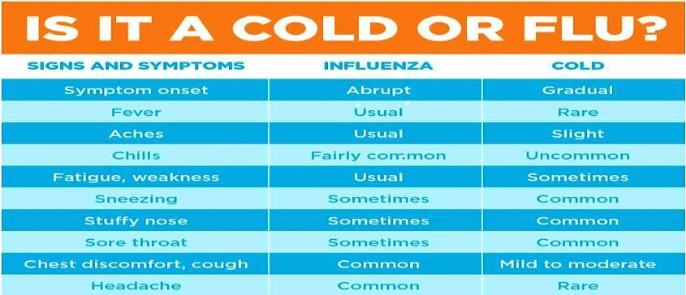

Managing Person Supported Who Are Ill
If a Person Supported in a SACL program becomes ill-with pandemic-like symptoms, the Services Manager should be immediately contacted.

Several options to support infected persons served are available depending on the severity of individual cases, and the number of person served who become ill with influenza.

Residential Programs
- Where possible, persons served in staffed residential homes that are ill and suspected to have a contagious disease, should be assessed by a medical practitioner immediately.
- Staff and management cannot determine the need for quarantine. This is a medical decision. If a pandemic related illness is confirmed by the medical practitioner, the affected person will be quarantined to prevent spread. If more than one person served is ill, or if quarantine measures do not appear to reduce the risks to others, it may be necessary to move people to healthcare facilities.
- If the infected person can tolerate mask wearing, they should be supported to wear a mask. If they are unable to wear a mask, staff providing care within 2 metres of them should wear a mask.
- If staff absence due to illness results in an inability to cover shifts at the minimum level individuals will be taken to hospital.
- Where possible there should be a 2 meter distance between ill people and others except when providing personal care including hygiene, toileting, mealtime supports and medication administration.
- If an outbreak occurs in the home, routine social visits will be limited or restricted and only essential visits/appointments will take place.

Non Essential Programs/Services
- The Services Manager should be notified immediately regarding of any person served who arrives at the program exhibiting signs of suspected influenza, or become ill during program hours. In such cases, the Services Manager will make arrangements to have family member/caregiver immediately pick the person up. In such cases, the person will be isolated from others while waiting for a family member/caregiver to arrive to take them home.
- If many people (staff and/or persons served) are becoming ill or the illness becomes highly prevalent in the Salmon Arm community, non-essential programs may be closed. Program Staff who are not ill may be deployed to other SACL programs which require staffing assistance.

Workplace Cleaning
During a pandemic, additional measures including more frequent cleaning and disinfecting are needed to minimize the transmission of the virus through environmental sources, particularly hard surfaces (e.g. countertops, sinks, faucets, appliances, doorknobs, railings, medical equipment, toys, toilets, phones, electronics, television remotes, objects and countertops). Transmission from contaminated hard surfaces is unlikely but influenza viruses may live up to two days on such surfaces.
Cleaning of environmental surfaces with Oxiver Plus is required. Surfaces which are frequently touched with hands should be cleaned often, a minimum of twice daily during a period of pandemic or as directed by the Services Manager. Every shift should have a designated staff to carry out general hygiene/sanitation.
See Appendix D for a sample enhanced cleaning checklist.
The table below suggests the appropriate choice and concentration of disinfectants:

Disinfectants | Recommended Use | Precautions
Oxiver Plus  To clean contaminated area, apply  a 1:40 solution per 25 mL of water  to the surface. | Apply to surface, allow to remain wet for 30 seconds then wipe dry | Keep out of reach of children  Flush eyes immediately if contacted  Contact a physician immediately if injested

When a person with suspected influenza is identified and has left the workplace, her/his work area/office, along with any other known places s/he has been, must be thoroughly cleaned and disinfected immediately.

SECTION 3: Training and Infection Control Protocols

Staff Training/Cross-Training
SACL will take measures to ensure that training and/or cross-training occurs so that essential services and/or critical business functions can continue. This may include:
- Cross-training of staff at different worksites
- Ensuring multiple staff are trained in critical business functions
- Training of non-staff supports
- Providing timely access to information systems (e.g. Nucleus, Payworks etc.) to ensure that profile and planning information is available to alternate staff/caregivers

Universal Precautions Training
- SACL will provide posters to hang in all washrooms, and in high traffic areas, to remind all staff and person served of proper hand washing techniques on an on-going basis.
- All staff must attend all training sessions related to infection prevention and control. Training sessions will include information on infection control in the workplace, including hand washing procedures.
- All staff must read, and provide their signature to verify they have read, all printed training materials.
- SACL will provide posters to hang in all public areas to remind all staff, visitors and person served of proper handwashing, coughing/sneezing etiquette on an on-going basis. A poster for hanging on the exterior door of the home/program reminding everyone to wash their hands before visiting can be found in Appendix A.
- All staff will be encouraged to be vaccinated for influenza. The vaccine is free for direct care workers.
- Latex and non-latex gloves will be available at all times for the use of all staff if so desired. Staff may be required to wear gloves at all times during their shift. Training on proper use of gloves will be provided to all staff.
- Training will be provided to all SACL persons served regarding proper hand washing procedures.
- Staff will be instructed to reassure persons served about their personal safety and health. Telling those we serve that it is okay to be concerned is comforting. Staff will reassure them they are safe and there are many things they can do to stay healthy, including:
    - Hand washing: Wash hands often with soap and warm water for at least 20 seconds, or use an alcohol based hand sanitizer, especially after coughing or sneezing.
    - Cough/sneeze etiquette: Cough and sneeze into arm or tissue.
    - Stay home when sick
    - Keep clean: Keep hands away from face and mouth.
    - Stay healthy by eating healthy foods, keeping physically active and getting enough sleep.

SECTION 4: Questions regarding Union Contract, Excluded
Employees and Applicable Legislation

Community Social Services Employers’ Association (CSSEA) has provided the following information regarding mandatory vaccines, time off, and employee/employer rights and responsibilities.

  - Can SACL insist that employees be vaccinated against pandemic influenza? If not, can SACL force un-vaccinated employees to stay away from the workplace?

Pursuant to Article 22.9 (c) of the Collective Agreements, if employees are asked to be vaccinated, employers must provide available vaccines to unionized employees at no cost to those employees.

  - Can I take time off to care for family members who are ill? Who qualifies as “family?”

Under Article 20.1(a) (Compassionate Leave) of the Collective Agreements, immediate family includes: a parent, (including step and foster-parent), spouse, common-law spouse, child, step-child, brother, sister, parent-in-law, grandparent, grandchild, legal guardian, ward and a relative permanently residing in the employee’s household. In such cases, employers will have to assess the reasonableness of such requests in light of their operational and staffing requirements.

Article 20.2 (Special Leave) of the Collective Agreements provides that a regular employee who has completed probation shall be entitled to special leave without pay to a maximum of ten (10) days per year to attend to:
(c) Serious household or domestic emergency including illness in the employee’s immediate family – up to two (2) days;
(i)…up to five (5) days of unpaid leave during each employment year to meet responsibilities related to:
    - the care, health or education of a child in the employee’s care, or
    - the care of health of any other member of the employee’s immediate family;

- Can I refuse to come to work during an epidemic?
Employees who are not showing symptoms of illness or who do not actively secure direction from a qualified medical professional to self-isolate are expected to attend, and remain at, work as scheduled, despite understandable personal concerns about potential exposure in the community or in the workplace. If an employee believes that the workplace is unsafe, he or she is entitled to refuse work until it is determined the workplace is safe. Caring for a person served who is ill would be considered unsafe if no supplies or training is provided to carry on the duties. If the workplace is deemed safe for workers, the employee must return to work. See section 3.12(1) of the Occupational Health and Safety Regulation.

- Do employees have privacy rights regarding their medical status or their exposure to infected individuals?

It is acceptable for SACL to ask a sick employee how contagious he/she might be, and with who he/she was in contact. Where an employee has fallen ill, it is also acceptable for employers to inform other employees that he/she may have been exposed to an illness. Additionally, employers may be able to advise that there might have been an exposure in the workplace, without disclosing who had the communicable disease.

- Do I need to follow the government’s instruction to self-isolate?
As the pandemic situation continues to evolve, the Health Officer may advise British Columbians to not travel outside of Canada or advise/direct those who choose to travel outside of Canada to self-isolate for a prescribed period of time when arriving back in BC. SACL will comply with and enforce such medical directives.

- If I am directed by a medical professional to self-isolate or remain in quarantine, will I be paid?
Employee isolation or quarantine for the 14 day incubation period should be done only with the approval of a medical professional unless the employee is returning from international travel, including from the United States. This is on the direction of the BC Medical Health Officer to self-isolate for 14 days in order to monitor for symptoms of the illness.

All other employees who have not travelled outside of Canada and who are concerned about having contracted the virus should contact 8-1-1, their primary care physician, or local public health office, to secure and follow directions on self-isolation, even though asymptomatic.

Employees who are medically directed to self-isolate will be placed on a paid leave of absence (not sick leave) for the duration of the recommended isolation period, unless they are able to work from home (e.g. complete online training, self-study competencies etc.)

Employees who commence travel outside of Canada after March 13, 2020 contrary to the direction of the Provincial MHO do so at their own risk. Upon returning to Canada, they would be placed on an unpaid leave for the 14 day self-isolation period, or they may use available vacation credits or apply for Employment Insurance (EI) benefits.

All self-isolating employees should be directed to keep their employer updated regarding the status of any direction or updates they receive from a qualified medical professional.

Appendix A - Essential Services Identification
The following is a list of services and the priority for delivery. Those service activities listed as Priority 1 are considered Essential Services that must be maintained during a pandemic Key:

Priority 1 | Potential to affect health and safety of the public or is legislated or required by law.
Priority 2 | Major inconvenience to the Person Served but does not significantly affect health and safety.
Priority 3 | Minor inconvenience to the Served; service probably not missed or could be deferred over the short term (6 weeks).

Service | Key Functions | Priority | Potential for Increased Demand
Residential Supports | Housing/shelter, supporting health/safety, personal care, meals, health/behavioural supports, other Activities of Daily Livings, emergency maintenance. | 1 | Medium  - May be increase in health/behavioural issues  - May require additional supports due for people who stay home from community-based services/activities
Home Share | Shared living, support with daily living | 1 | Medium  - May require additional supports due to persons staying home from community based activities
Supported Independent Living/Outreach | Assisting people with daily living skills at their home or in community. | 2-3 | Low  - Services may be more important for certain persons who are at higher risk without supports
Community Inclusion/Day Services | CI activities at community and/or group CI sites | 2-3 | Low  - Services may be more important for certain persons who are at higher risk without supports
Employment | Supported employment | 3 | Low

. Appendix B – Critical Business Functions and Resources
Critical Business Functions and Resources
Critical Accounting

1. | Critical Business Function/Position | EFTs and essential accounts payable
2. | Employee(s) responsible for function | Shuswap Bookkeeping Services (SB), Executive Director
3. | Critical functions performed | Accounts Payable, EFT’s
4. | Other staff who are cross-trained | The Executive Director would be able to complete these functions manually if required.
5. | Cross-training on other positions | N/A
6. | Other staff, temps or retirees who could perform the duties | This function would fall to the Board of Directors should the appropriate parties not be able to fulfill their duties
7. | Does the current incumbent have school age children at home? | Yes
8. | How does the current incumbent  travel to work (i.e. transit, carpool,  SOV) | The incumbent works from home with another staff member working in a one-man office or from home as required. When travelling to work/office incumbents use personal vehicles.
9. | Does the employee(s) work allow for shift work (i.e. 6:00 a.m. to 1:30 p.m. or 2:00 p.m. to 9:30 p.m.)? If so, identify which shift would work better. | Available during regular office hours as well as after hours for emergencies.
10. | Software that may be needed to perform the job. | Sage 50

Shuswap Bookkeeping has a full contingency plan on file with the agency outlining specific procedures.

Critical Communications

1. | Critical Business Function/Position | Critical Communications
2. | Employee(s) responsible for function | Executive Director, Administrative Supervisor
3. | Critical functions performed | - Provide up to date information to stakeholders, staff & community members  - Executive Director provides and relays information to the public  - Admin. Supervisor updates website and produces printed material upon request
4. | Other staff who are cross-trained | None
5. | Cross-training on other positions | The Administrative Supervisor is trained in IT functions, OH&S functions and other Administrative functions
6. | Other staff, temps or retirees who could perform the duties | This would fall to the Board of Directors to speak on behalf of the agency should the Executive Director not be available.  Other outside sources such as iDream Digital would be able to update information on our website should the Admin. Supervisor not be available.
7. | Does the current incumbent have school age children at home? | One does, one does not.
8. | How does the current incumbent  travel to work (i.e. transit, carpool,  SOV) | Personal Vehicles
9. | Does the employee(s) work allow for shift work (i.e. 6:00 a.m. to 1:30 p.m. or 2:00 p.m. to 9:30 p.m.)? If so, identify which shift would work better. | Both incumbents work regular day time office hours. (Monday – Friday, 8:00 am – 4:00 pm). Both are available after hours to the Management Team in an emergency.
10. | Software that may be needed to perform the job. | WordPress (website)  Microsoft Office (Letters)  Nucleus (Communication Logs/Com-boxes)

Critical Health & Safety Functions

1. | Critical Business Function/Position | Critical Health & Safety Functions (Including staff injury & reporting)
2. | Employee(s) responsible for function | Administrative Supervisor, OH&S Committee
3. | Critical functions performed | - Reporting Staff injuries to WSBC  - Investigating in conjunction with OH&S worker representatives, any reports of serious health & safety violations  - Suggesting implementations of corrective actions
4. | Other staff who are cross-trained | There is one other Employer Representative and three worker representatives that can conduct investigations, however at this time there is no others trained to submit information to WSBC. Services Managers have had some training for submissions.
5. | Cross-training on other positions | Worker representatives and Services Mangers are trained to provide front line services.  The Admin. Supervisor is trained for IT, Information updating & other Administrative functions.
6. | Other staff, temps or retirees who could perform the duties | There are 2 other staff members that are ‘alternate’ worker representatives that would be able to participate in an investigation.
7. | Does the current incumbent have school age children at home? | Some of the above mentioned do.
8. | How does the current incumbent  travel to work (i.e. transit, carpool,  SOV) | Personal Vehicles
9. | Does the employee(s) work allow for shift work (i.e. 6:00 a.m. to 1:30 p.m. or 2:00 p.m. to 9:30 p.m.)? If so, identify which shift would work better. | Shifts of above workers are variable, including evening & overnight shifts. However most common is Monday – Friday day shifts (aprox. 8:00 am – 4:00 pm)
10. | Software that may be needed to perform the job. | Web access for reporting to WSBC.

Payroll & Expenses

1. | Critical Business Function/Position | Processing Payroll & Expenses for automatic deposits
2. | Employee(s) responsible for function | Shuswap Bookkeeping Services (SB),
3. | Critical functions performed | Shuswap Bookkeeping – Receiving finalized payroll/expenses & processing for deposit.
4. | Other staff who are cross-trained | Services Managers & ED prepare payroll for SB so are trained in all but final processing.  Admin. Supervisor & Services Managers prepare expense submissions for submission but can’t complete for deposit.  Final payout can be done manually (hand written cheques) if necessary.
5. | Cross-training on other positions | Shuswap Bookkeeping is trained in all accounting/financial aspects, however as a separate contractor providing only those services are not cross trained for other areas of service.
6. | Other staff, temps or retirees who could perform the duties | Shuswap Bookkeeping has 2 staff members trained in these duties. There is also technological back-up, and the employees can work from home during isolation with full access to technology and security for processing & payment.
7. | Does the current incumbent have school age children at home? | Yes
8. | How does the current incumbent  travel to work (i.e. transit, carpool,  SOV) | The incumbent works from home with another staff member working in a one-man office or from home as required. The worker travels to work by personal vehicle.
9. | Does the employee(s) work allow for shift work (i.e. 6:00 a.m. to 1:30 p.m. or 2:00 p.m. to 9:30 p.m.)? If so, identify which shift would work better. | Available during regular office hours as well as after hours for emergencies.
10. | Software that may be needed to perform the job. | Pay Works, Sage 50, CAFT

Shuswap Bookkeeping has a full contingency plan on file with the agency outlining specific procedures.

Personnel Issues (Serious or Urgent)

1. | Critical Business Function/Position | Serious or Urgent Personnel Issues
2. | Employee(s) responsible for function | Executive Director/Services Managers
3. | Critical functions performed | - Personnel Support & Instruction  - Debriefing for Critical Incidents  - Discipline & Corrective Actions
4. | Other staff who are cross-trained | The management team is cross trained in most aspects of these functions, requiring approval for some disciplinary items from the Executive Director.
5. | Cross-training on other positions | The Services Managers are trained to work as front-line support if required
6. | Other staff, temps or retirees who could perform the duties
7. | Does the current incumbent have school age children at home? | 2 of the 4 incumbents have school age children at home.
8. | How does the current incumbent  travel to work (i.e. transit, carpool,  SOV) | Personal vehicles
9. | Does the employee(s) work allow for shift work (i.e. 6:00 a.m. to 1:30 p.m. or 2:00 p.m. to 9:30 p.m.)? If so, identify which shift would work better. | The ED and Service Managers work day time hours regularly, 8:00 am – 4:00 pm from Monday to Friday. There is always a Services Manager (or designate) available 24/7 on the agency emergency cell phone, and the ED is available to the Services Managers via phone after hours in an emergency
10. | Software that may be needed to perform the job. | Payworks, Nucleus (web based systems)

Critical IT Systems

1. | Critical Business Function/Position | Maintaining Critical IT Systems
2. | Employee(s) responsible for function | Internal Systems  Administrative Supervisor  External Systems  Services Manager (Joanne Reitan)  Shuswap Bookkeeping
3. | Critical functions performed | Internal Systems: Maintain security, back-up, updates and function of internal server, computers and components in conjunctions with IT professionals Faster Than Light Computing  External Systems: Communicate and coordinate with Nucleus and PayWorks systems (web based) to ensure continuity of service and function.
4. | Other staff who are cross-trained | Internal Systems: Faster Than Light IT professionals are our back-up should issues not be able to be addressed internally.  External Systems: Any member of the Executive Team would be authorized to contact Nucleus/PayWorks to provide instruction or gain information on the system.
5. | Cross-training on other positions | All Managers are trained to work front line positions if required.
6. | Other staff, temps or retirees who could perform the duties | N/A
7. | Does the current incumbent have school age children at home? | Yes
8. | How does the current incumbent  travel to work (i.e. transit, carpool,  SOV) | Personal Vehicles
9. | Does the employee(s) work allow for shift work (i.e. 6:00 a.m. to 1:30 p.m. or 2:00 p.m. to 9:30 p.m.)? If so, identify which shift would work better. | Executive Team and IT partners work regular day-time hours (Monday – Friday, 8:00 am – 4:00 pm). IT emergencies for internal issues may be available after hours in an emergency situation.
10. | Software that may be needed to perform the job. | Internal: Ninja, TeamViewer, various programs  External: Nucleus, PayWorks,

. Appendix C – Resource Pandemic Preparedness Risk Assessment Plan

1st Avenue Home Support Services (Supported Living)

Name of Resource: SL 1st Ave
Manager: Claudia Pass
Worker Health and Safety Rep: Toni Roberge
Number of Persons Supported: 1

Essential Activities
Define essential activities. “Essential” includes anything required for the health and safety of the person and/or activities that could not be suspended for more than 2-3 weeks without significant impact on the person’s well being. Examples include housing/shelter, personal care, health and behavioural support, food provision, and any other critical tasks.
24/7 supports required for health and behavioural supports. Taking person served in the van for a drive daily, Personal care is required, all meals are prepared in house and we are ordering on line for grocery pick up.
Essential Staffing Levels
Determine minimum staffing levels required to carry out essential activities. Include the number of staff and the times required (e.g. 2 staff from 9am-9pm, 1 staff from 9pm-9am).
1 staff from 8:30am-4:30pm, 1 staff from 4:30pm-10:30pm, 1 staff from 10:30pm-8:30am
Service Adjustments
Outline what adjustments can be made to service provision to mitigate the risk of exposure and/or outbreak. Consider such issues as what activities are offered, where activities are offered, how risks can be mitigated with current activities, environmental considerations and support strategies.
Majority of supports are normally in-house or 1:1 in van so minimal service adjustments are required. We have cancelled all recycling pick up and now are reusing the recycling that person served has already worked with. We are using a Tim Hortons card so we do not have to handle cash. There is sanitizer and masks at the front door of PS house for all to use when entering and exiting the house. All staff are Disinfecting Door knobs, Light switches and all household items.
Supplies and Resources
What will need to be done to ensure proper supplies and resources are available in case of an outbreak?
We have already ordered some stock in gloves, laundry soap, toilet paper, and we are fully stocked with Oxivir Plus Disinfectant Cleaner. Will need to ensure appropriate PPE is on hand should person supported become infected as staff will need to continue to work in the home to provide supports.
Communication
How will you communicate information to persons supported, staff, families and other stakeholders?
Via E-mail, Com-Box, Communication Log, phone, or text.
Staffing Barriers and Response Plan
Identify any staffing barriers specific to the resource that may require planning. This may include staff who may need to care for others who are vulnerable or who may not have access to other supports (e.g. children during school closures, the elderly), staff who may not have transportation if public transportation is not available, etc.
We do have staff who are primary caregivers to others who are elderly, immunocompromised and/or young children. If schools or daycares closed, we may have staff who can only work from home. Unless many requests lay offs, or are unable to work for other reasons, we’d have enough staff to fulfill required supports
Alternate Staffing/Support Provision Options
List options within your resource for ensuring support should a staffing become critically low. Consider the following: family members or other non-SACL supports; former staff; staff at other SACL resources; SACL volunteers; staff who could take persons to their own home (with Director approval)
In the event staffing was critically low management, other SACL staff currently working from home, and possibly staff who recently left SACL could be utilized for direct support.
Training Plan
Is there any training that could happen in advance of an outbreak, such as with alternate staffing/support providers listed above.
SACL has many staff who are trained to work at 1st Avenue. For some it has been awhile since they have worked in this location; a services manager may need to do a few hours of training with these staff to re-orient them.
Resource Specific Considerations for Outbreaks/Exposure
Are there any unique considerations for responding to an outbreak or potential exposure to a virus within your resource? You may Consult information from the BCCDC and/or local health authority for information on potential response measures.

5th Avenue Home Support (Supported Living)
Name of Resource: SL 5th Street
Manager: Claudia Pass
Worker Health and Safety Rep: Toni Roberge
Number of Persons Supported: 6

Essential Activities
Define essential activities. “Essential” includes anything required for the health and safety of the person and/or activities that could not be suspended for more than 2-3 weeks without significant impact on the person’s well being. Examples include housing/shelter, personal care, health and behavioural support, food provision, and any other critical tasks.
To maintain health, safety, and behavioural supports around some recent incidents, regular staffing levels are currently required. Will continually re-assess whether these levels need to be in place on-going.
Essential Staffing Levels
Determine minimum staffing levels required to carry out essential activities. Include the number of staff and the times required (e.g. 2 staff from 9am-9pm, 1 staff from 9pm-9am).
1 staff 8:30 am – 3:30 pm, 1 staff 12:00 pm – 7:00 pm
Service Adjustments
Outline what adjustments can be made to service provision to mitigate the risk of exposure and/or outbreak. Consider such issues as what activities are offered, where activities are offered, how risks can be mitigated with current activities, environmental considerations and support strategies.
To minimize exposure, persons living in the homes are being encouraged to stay at home, and have been told that non-essential visitors need to be avoided. Staff are encouraging persons supported to engage in outdoor activities while maintaining social distancing.
Supplies and Resources
What will need to be done to ensure proper supplies and resources are available in case of an outbreak?
Supplies required include soap, hand sanitizer, paper towels, gloves, masks, tissues. Suppliers are operating through online orders. Will need to ensure appropriate PPE is on hand should person supported become infected as staff will need to continue to work in the home to provide supports and monitor for changes in health requiring hospitalization.
Communication
How will you communicate information to persons supported, staff, families and other stakeholders?
Via E-mail, Com-Box, Communication Log, phone, or text.
Staffing Barriers and Response Plan
Identify any staffing barriers specific to the resource that may require planning. This may include staff who may need to care for others who are vulnerable or who may not have access to other supports (e.g. children during school closures, the elderly), staff who may not have transportation if public transportation is not available, etc.
We do have staff who are primary caregivers to others who are elderly, immunocompromised and/or young children. If schools or daycares closed, we may have staff who can only work from home. Unless many requests lay offs, or are unable to work for other reasons, we’d have enough staff to fulfill required supports.
Alternate Staffing/Support Provision Options
List options within your resource for ensuring support should a staffing become critically low. Consider the following: family members or other non-SACL supports; former staff; staff at other SACL resources; SACL volunteers; staff who could take persons to their own home (with Director approval)
In the event staffing was critically low management, other SACL staff currently working from home, and possibly staff who recently left SACL could be utilized for direct support. Some persons supported may be able to re-locate to family members home or have family member provide supports.
Training Plan
Is there any training that could happen in advance of an outbreak, such as with alternate staffing/support providers listed above.
SACL has many staff who are trained to work at 5th Street. Very little training is required for other staff members to be able to competently work at the home. They would be able to receive the information they require via emails or a phone call from services manager.
Resource Specific Considerations for Outbreaks/Exposure
Are there any unique considerations for responding to an outbreak or potential exposure to a virus within your resource? You may Consult information from the BCCDC and/or local health authority for information on potential response measures.

One-to-One Supports (PEP)

Name of Resource: Community Inclusion 1:1 Supports
Manager: Karen Hansen, Joanne Reitan
Worker Health and Safety Rep: Toni Roberge
Number of Persons Supported: 19

Essential Activities
Define essential activities. “Essential” includes anything required for the health and safety of the person and/or activities that could not be suspended for more than 2-3 weeks without significant impact on the person’s well being. Examples include housing/shelter, personal care, health and behavioural support, food provision, and any other critical tasks.
Community Inclusion 1:1 supports a number of individuals for whom ongoing support is essential to their overall wellbeing and behavioural support. Several are in home share placements that would be at risk of breaking down without CI support. For some, who live independently SACL is their only support system so regular check ins must occur to ensure their health and safety is maintained.
Essential Staffing Levels
Determine minimum staffing levels required to carry out essential activities. Include the number of staff and the times required (e.g. 2 staff from 9am-9pm, 1 staff from 9pm-9am).
All persons supported in Community Inclusion 1:1 supports are 1:1 so minimum number is dependent on the number of persons requiring service. Of those who we deem essential, a minimum of four staff are necessary during the hours of 8:30-3:30. During those hours, staff would also be able to provide check ins for persons who chose to stay home during the pandemic.
Service Adjustments
Outline what adjustments can be made to service provision to mitigate the risk of exposure and/or outbreak. Consider such issues as what activities are offered, where activities are offered, how risks can be mitigated with current activities, environmental considerations and support strategies.
Many of the community activities in which persons normally participate are closed as a result of the pandemic; outdoor activities are encouraged. Ensuring few people in program space in order to maintain social distance is critical. Staff may be deployed to meet persons in community or pick up from their homes when they’d otherwise be dropped off at the program. Technology may be used for remote support (ie. phone calls, Skype). Thorough sanitation of surfaces in the program as well as staff vehicles is required along with regular handwashing, and using hand sanitizer. Tissues should be used when touching ones face and anyone showing symptoms of illness must stay home.
Supplies and Resources
What will need to be done to ensure proper supplies and resources are available in case of an outbreak?
Supplies required include soap, hand sanitizer, paper towels, gloves, masks, tissues. Suppliers are operating through online orders.
Communication
How will you communicate information to persons supported, staff, families and other stakeholders?
Telephone calls, emails, Facetime or Skype, website. All contact is to be recorded in persons supported Nucleus stat notes.
Staffing Barriers and Response Plan
Identify any staffing barriers specific to the resource that may require planning. This may include staff who may need to care for others who are vulnerable or who may not have access to other supports (e.g. children during school closures, the elderly), staff who may not have transportation if public transportation is not available, etc.
We do have staff who are primary caregivers to others who are elderly, immunocompromised and/or young children. If schools or daycares closed, we may have staff who can only work from home. Unless many requests lay offs, or are unable to work for other reasons, we’d have enough staff to fulfill required supports.
Alternate Staffing/Support Provision Options
List options within your resource for ensuring support should a staffing become critically low. Consider the following: family members or other non-SACL supports; former staff; staff at other SACL resources; SACL volunteers; staff who could take persons to their own home (with Director approval)
In the event staffing was critically low and supports in program weren’t possible, some families or home share providers may need access to respite caregivers for support. Management, CES staff and possibly staff who recently left SACL could be utilized for direct support.
Training Plan
Is there any training that could happen in advance of an outbreak, such as with alternate staffing/support providers listed above.
SACL has many staff who are trained to work with 1:1 persons.
Resource Specific Considerations for Outbreaks/Exposure
Are there any unique considerations for responding to an outbreak or potential exposure to a virus within your resource? You may Consult information from the BCCDC and/or local health authority for information on potential response measures.

Community Connector Network

Name of Resource: Community Inclusion – Community Connector Network
Manager: Joanne Reitan
Worker Health and Safety Rep: Toni Roberge
Number of Persons Supported: 6

Essential Activities
Define essential activities. “Essential” includes anything required for the health and safety of the person and/or activities that could not be suspended for more than 2-3 weeks without significant impact on the person’s well being. Examples include housing/shelter, personal care, health and behavioural support, food provision, and any other critical tasks.
None of the activities in this service are deemed essential.
Essential Staffing Levels
Determine minimum staffing levels required to carry out essential activities. Include the number of staff and the times required (e.g. 2 staff from 9am-9pm, 1 staff from 9pm-9am).
None – services not essential.
Service Adjustments
Outline what adjustments can be made to service provision to mitigate the risk of exposure and/or outbreak. Consider such issues as what activities are offered, where activities are offered, how risks can be mitigated with current activities, environmental considerations and support strategies.
Because the purpose of this service is to connect with the community, and businesses have closed, groups of people are being discouraged, social distancing is being encouraged, it is virtually impossible to successfully operate the majority of this service.
Supplies and Resources
What will need to be done to ensure proper supplies and resources are available in case of an outbreak?
Supplies required include soap, hand sanitizer, paper towels, gloves, masks, tissues. Suppliers are operating through online orders.
Communication
How will you communicate information to persons supported, staff, families and other stakeholders?
Telephone calls, emails, Facetime or Skype, website. All contact is to be recorded in persons supported Nucleus stat notes.
Staffing Barriers and Response Plan
Identify any staffing barriers specific to the resource that may require planning. This may include staff who may need to care for others who are vulnerable or who may not have access to other supports (e.g. children during school closures, the elderly), staff who may not have transportation if public transportation is not available, etc.
Because this service is deemed non-essential, staffing is not an issue.
Alternate Staffing/Support Provision Options
List options within your resource for ensuring support should a staffing become critically low. Consider the following: family members or other non-SACL supports; former staff; staff at other SACL resources; SACL volunteers; staff who could take persons to their own home (with Director approval)
Because this service is deemed non-essential, staffing is not an issue.
Training Plan
Is there any training that could happen in advance of an outbreak, such as with alternate staffing/support providers listed above.
Because this service is deemed non-essential, training is not an issue.
Resource Specific Considerations for Outbreaks/Exposure
Are there any unique considerations for responding to an outbreak or potential exposure to a virus within your resource? You may Consult information from the BCCDC and/or local health authority for information on potential response measures.

Community Employment Services (CES)

Name of Resource: Community Employment Supports
Manager: Joanne Reitan
Worker Health and Safety Rep: Toni Roberge
Number of Persons Supported: 36

Essential Activities
Define essential activities. “Essential” includes anything required for the health and safety of the person and/or activities that could not be suspended for more than 2-3 weeks without significant impact on the person’s well being. Examples include housing/shelter, personal care, health and behavioural support, food provision, and any other critical tasks.
If a person supported is receiving job supports, their place of employment is still operational, and not having supports would put their job at risk. Many people we support in maintenance, we are their only point of contact with CLBC – SACL needs to keep in contact with them to ensure their basic needs are still met should they be laid off from their employment due to pandemic (eg. Do they have adequate money to pay for housing and food).
Essential Staffing Levels
Determine minimum staffing levels required to carry out essential activities. Include the number of staff and the times required (e.g. 2 staff from 9am-9pm, 1 staff from 9pm-9am).
As of March 19, none of the persons supported through CES require job coaching. 15 persons are supported in job maintenance. Minimum staffing required – 1 staff, 1 day per week 8:30 am – 3:30 pm.
Service Adjustments
Outline what adjustments can be made to service provision to mitigate the risk of exposure and/or outbreak. Consider such issues as what activities are offered, where activities are offered, how risks can be mitigated with current activities, environmental considerations and support strategies.
Many of the businesses in Salmon Arm are closed, WorkBC is closed, and because of social distancing employers do not want to meet with staff or potential job candidates; therefore, most of the regular activities of job development will need to be suspended. Staff can continue to update resumes – when appropriate communicating with person supported via email to get their input regarding resumes. Staff can attempt to market services via telephone to those businesses that are open.

Regarding Employment Supports, if it is discovered that a person supported job is in jeopardy or someone has been laid off and basic needs are not being met, staff can work 1:1 with them to give job-in-jeopardy supports or to assist them to find supports to meet basic needs.

CES staff may be deployed to other services as they are cross-trained and can be back-up staff in the case of illness in our essential service areas/supports.
Supplies and Resources
What will need to be done to ensure proper supplies and resources are available in case of an outbreak?
Supplies required include soap, hand sanitizer, paper towels, gloves, masks, tissues. Suppliers are operating through online orders.
Communication
How will you communicate information to persons supported, staff, families and other stakeholders?
Telephone calls, texts, emails, Facetime or Skype, website. All contact is to be recorded in persons supported Nucleus stat notes.
Staffing Barriers and Response Plan
Identify any staffing barriers specific to the resource that may require planning. This may include staff who may need to care for others who are vulnerable or who may not have access to other supports (e.g. children during school closures, the elderly), staff who may not have transportation if public transportation is not available, etc.
There are 4 staff trained to work at CES and for essential services, only 1 staff, 1 day per week is required, staffing should not be an issue in this program area.
Alternate Staffing/Support Provision Options
List options within your resource for ensuring support should a staffing become critically low. Consider the following: family members or other non-SACL supports; former staff; staff at other SACL resources; SACL volunteers; staff who could take persons to their own home (with Director approval)
In the event staffing was critically low, management, or with management support another staff would be able to take over making needed connections.
Training Plan
Is there any training that could happen in advance of an outbreak, such as with alternate staffing/support providers listed above.
Not deemed necessary.
Resource Specific Considerations for Outbreaks/Exposure
Are there any unique considerations for responding to an outbreak or potential exposure to a virus within your resource? You may Consult information from the BCCDC and/or local health authority for information on potential response measures.

Health, Wellness & Life Skills Services (HWLS)

Name of Resource: Community Inclusion Health Wellness and Life Skills
Manager: Joanne Reitan
Worker Health and Safety Rep: Toni Roberge
Number of Persons Supported: 39

Essential Activities
Define essential activities. “Essential” includes anything required for the health and safety of the person and/or activities that could not be suspended for more than 2-3 weeks without significant impact on the person’s well being. Examples include housing/shelter, personal care, health and behavioural support, food provision, and any other critical tasks.
For a small portion of the population who receive services from HWLS ongoing support is essential to their overall wellbeing and behavioural support. A suspension of services would create hardship to their parent or caregiver – for example, they work and if they did not have day programs, other supports would need to be secured. Others are in home share placements that would be at risk of breaking down without CI support. Every person supported and/or their primary caregiver has been contacted to determine whether or not they feel HWLS day services are essential based on any of the criteria listed.
Essential Staffing Levels
Determine minimum staffing levels required to carry out essential activities. Include the number of staff and the times required (e.g. 2 staff from 9am-9pm, 1 staff from 9pm-9am).
In order to allow for social distancing, 1:1 or 1:2 supports (depending on activity) would need to be put in place for those whose services have been deemed essential. As of March 19, 3 persons supported services at HWLS have been deemed essential. Therefore minimum staffing required is 3 from 8:3o am to 3:30 pm. During these hours, staff would also provide check ins for persons who chose to stay home during the pandemic to determine whether their situation had changed and they are now in need of services.
Service Adjustments
Outline what adjustments can be made to service provision to mitigate the risk of exposure and/or outbreak. Consider such issues as what activities are offered, where activities are offered, how risks can be mitigated with current activities, environmental considerations and support strategies.
Many of the community activities in which persons normally participate are closed as a result of the pandemic; outdoor activities are encouraged. Instead of larger group activities that usually occur at HWLS, supports will be provided 1:1 or 1:2. 1:2 could occur if individuals were in the same program space but practicing social distancing.

Regular check ins will occur to determine if a change in circumstances at home makes the service essential. If more individuals are requiring services, individuals could attend only part of their regular schedule. For example, if they regularly attend for 5 days per week, they could attend for 3. Or services can be offered for part days when the person would normally attend full days.

Staff may be deployed to meet persons in community or pick up from their homes when they’d otherwise be dropped off at the program.

Thorough sanitation of surfaces in the program as well as staff vehicles is required along with regular handwashing, and using hand sanitizer. Tissues should be used when touching ones face and anyone showing symptoms of illness must stay home. Social stories provided to teach persons supported how to keep themselves and others safe.
Supplies and Resources
What will need to be done to ensure proper supplies and resources are available in case of an outbreak?
Supplies required include soap, hand sanitizer, paper towels, gloves, masks, tissues. Suppliers are operating through online orders.
Communication
How will you communicate information to persons supported, staff, families and other stakeholders?
Telephone calls, texts, emails, website. All contact is to be recorded in persons supported Nucleus stat notes.
Staffing Barriers and Response Plan
Identify any staffing barriers specific to the resource that may require planning. This may include staff who may need to care for others who are vulnerable or who may not have access to other supports (e.g. children during school closures, the elderly), staff who may not have transportation if public transportation is not available, etc.
We do have staff who are primary caregivers to others who are elderly, immunocompromised and/or young children. If schools or daycares closed, we may have staff who work from home require a leave of absence/lay-off. Unless many request absences for other reasons, we’d have enough staff to fulfill required supports.
Alternate Staffing/Support Provision Options
List options within your resource for ensuring support should a staffing become critically low. Consider the following: family members or other non-SACL supports; former staff; staff at other SACL resources; SACL volunteers; staff who could take persons to their own home (with Director approval)
In the event staffing was critically low, management, CES staff and possibly staff who recently left SACL could be utilized for direct support. As above, could consider reduced number of hours of support to persons supported whose services have been deemed essential, so that each receives partial supports.
Training Plan
Is there any training that could happen in advance of an outbreak, such as with alternate staffing/support providers listed above.

Home Share Services (HS)

Name of Resource: Home Share Services
Manager: Karen Hansen
Worker Health and Safety Rep: Toni Roberge
Number of Persons Supported: 8

Essential Activities
Define essential activities. “Essential” includes anything required for the health and safety of the person and/or activities that could not be suspended for more than 2-3 weeks without significant impact on the person’s well being. Examples include housing/shelter, personal care, health and behavioural support, food provision, and any other critical tasks.
All support within home sharing is essential.
Essential Staffing Levels
Determine minimum staffing levels required to carry out essential activities. Include the number of staff and the times required (e.g. 2 staff from 9am-9pm, 1 staff from 9pm-9am).
We currently have eight persons living with seven home share providers.
Service Adjustments
Outline what adjustments can be made to service provision to mitigate the risk of exposure and/or outbreak. Consider such issues as what activities are offered, where activities are offered, how risks can be mitigated with current activities, environmental considerations and support strategies.
Home isolation would be possible in home share. Information would need to be shared with home share providers on the recommendations from the Health Authority.
Supplies and Resources
What will need to be done to ensure proper supplies and resources are available in case of an outbreak?
Home Share Providers are contracted caregivers and responsible for insuring they have all supplies required.
Communication
How will you communicate information to persons supported, staff, families and other stakeholders?
Phone calls, email, website. All discussions to be documented in persons supported Nucleus Stat Notes.
Staffing Barriers and Response Plan
Identify any staffing barriers specific to the resource that may require planning. This may include staff who may need to care for others who are vulnerable or who may not have access to other supports (e.g. children during school closures, the elderly), staff who may not have transportation if public transportation is not available, etc.
SACL currently has no home share providers who would be unable to care for the persons supported during any such circumstances.
Alternate Staffing/Support Provision Options
List options within your resource for ensuring support should a staffing become critically low. Consider the following: family members or other non-SACL supports; former staff; staff at other SACL resources; SACL volunteers; staff who could take persons to their own home (with Director approval)
Should a Home Share provider become ill themselves, many persons have family with whom they could stay. SACL has one pre-screened home share provider that could be used as support if needed and one home share provider has space to accommodate one more person.
Training Plan
Is there any training that could happen in advance of an outbreak, such as with alternate staffing/support providers listed above.
Training would be required if SACL had to use the available resources as listed above. The coordinator would be responsible to ensure all necessary information is given to temporary placement.
Resource Specific Considerations for Outbreaks/Exposure
Are there any unique considerations for responding to an outbreak or potential exposure to a virus within your resource? You may Consult information from the BCCDC and/or local health authority for information on potential response measures.

. Appendix D – Resource Materials – Checklists & Signage

Cleaning Checklist

SAMPLE: Enhanced Cleaning Guidelines for Pandemic Outbreaks
* Each shift needs to have a staff member appointed as the hygiene/sanitation manager.
** Surfaces which are frequently touched with hands should be cleaned often, a minimum of twice daily during a period of pandemic or more frequently as directed by the Services Manager.
Frequently Touched Surfaces | Check off as completed
Cleaning agent to be used:
1. Kitchen/Dining
(a) Counters
(b) Chairs
(c) Light switches
(d) Kitchen sink and faucet
(e) Small Appliances (e.g. coffee maker/blender)
(f) Large Appliances (e.g. fridge/stove/microwave/dishwasher)
(g) Cabinet and drawer knobs and handles
(h) Floor
(i) Other:
2. Washroom(s):
(a) Sink basin and faucet
(b) Toilet (lever/flush, horizontal surfaces, seat)
(c) Tub and shower, including handles and plugs
(c) Floor
(d) Soap dispenser
(e) Paper towel dispenser
(f) Light switch
(g) Door and handles on entry and exit
3. Meeting/Living Room(s):
(a) Door and knob on entry and exit
(b) Telephone
(c) Chairs/couches (if able) and end tables
(d) Electronics including remotes (e.g. ipads/stereos/speakers)
(e) Other:
4. Office spaces:
(a) Door knob on entry and exit
(b) Door (where hands commonly touch to push open)
(d) Desk and Phone
(e) Keyboard and Mouse

5. Program Vehicles:
(a) Exterior and interior handles
(b) Seats (if able)
(c) Steering wheel, knobs and glove box
6. Laundry and Storage Rooms:
- Door and knob on entry and exit
- Washer and dryer control knobs and doors
7. Bedrooms:
(a) Bedroom furniture
(b) Door knobs and closet doors
(c) Laundry basket
(d) Transfer poles
(e) Other
8. Medication Room:
(a) Door knob on entry and exit
(b) Door (where hands commonly touch to push open)
(c) Counters & cupboard doors
(d) Blister pack racks/holders
(e) Light switches
(f) Sink
8. Medical Equipment:
(a) Wheelchairs, (handles/armrests/brakes/wheels/gear box)
(b) Commodes
(c) Electric lift motor
(d) Slings – washed daily and when soiled
(e) G-tube pumps
(f) Hospital bed rails
(g) Other:

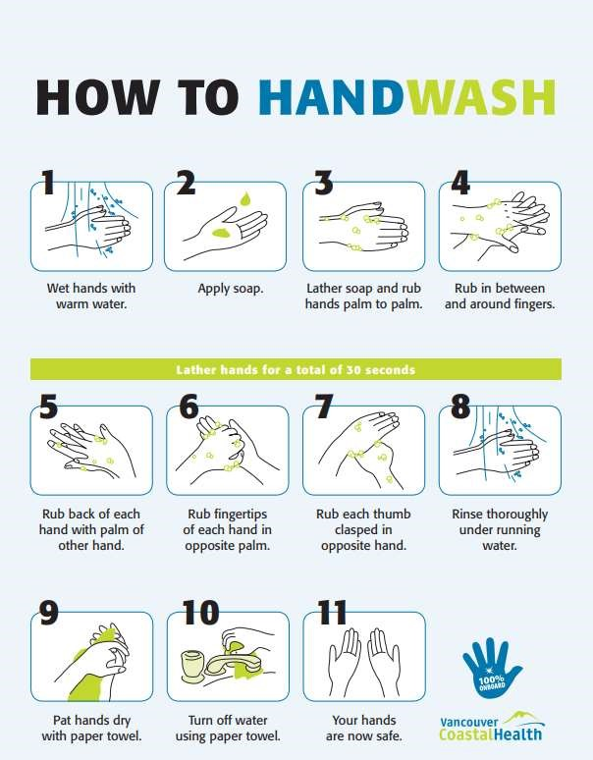

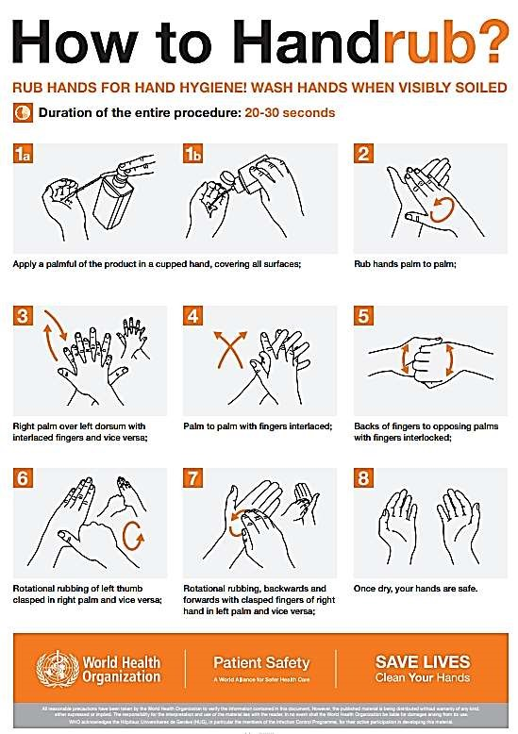
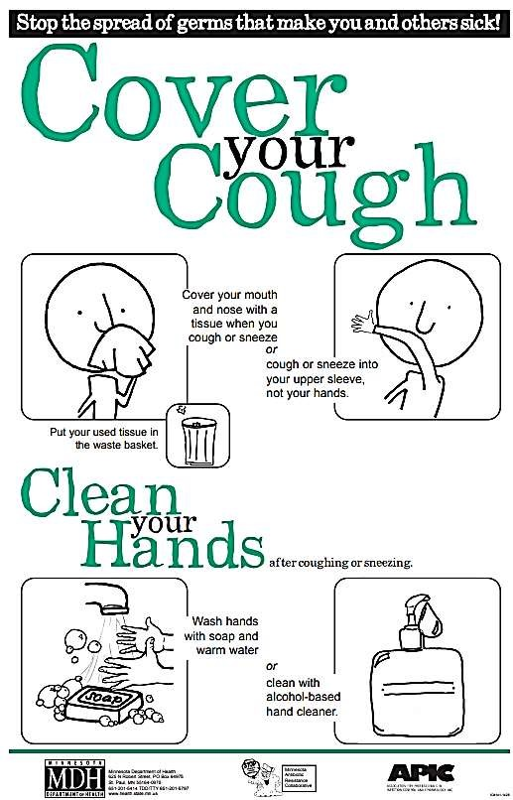

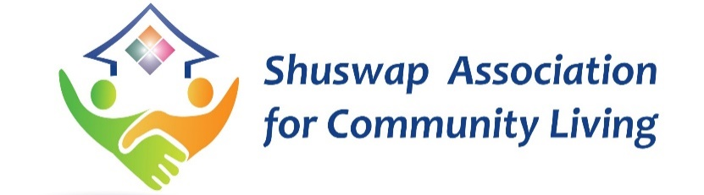
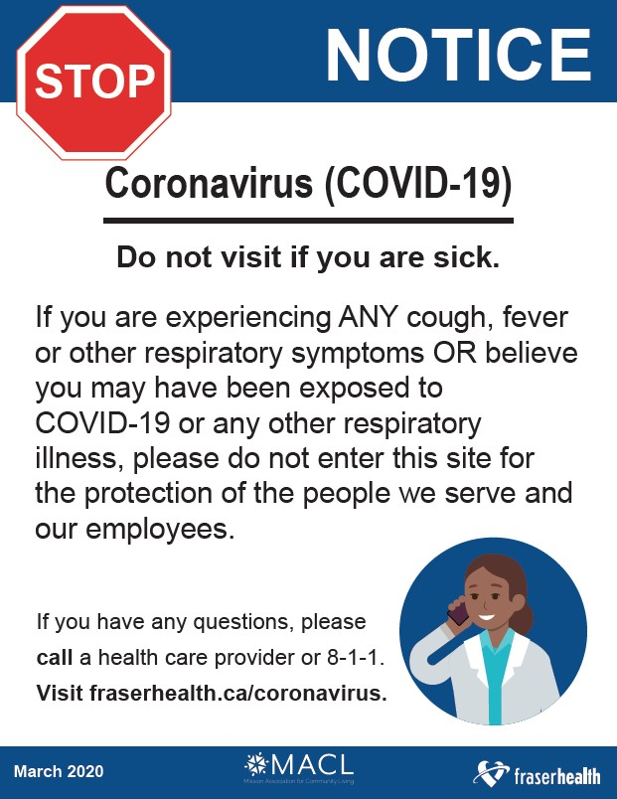

Attention

Due to the current pandemic, we ask that you do not enter if you are sick.

Please wash your hands when you enter, before visiting others, using the washroom, coughing/sneezing and when leaving.

Thank-you for your part in keeping us safe!

