Services
Handbook
2022

For People Receiving Services, their Families and Caregivers
www.shuswapacl.com

INDEX
Mission, Vision, Values 3

Who We Are 4
Our Funding Sources 4
CARF Accreditation 4
Governance and Leadership 5
Organizational Chart 6

What We Do 7
Access to Service 7
Dignity of Risk 7
Shuswap Self Advocates Bill of Rights 8
Person Centred Plan (PCP) & Employment Plans 10
Staff 11
Key Worker System 12
Individual/Stakeholder Input 12
Costing & Fees 13
Reasonable Accommodations 13

Service Listing 14

Agency Policies & Guidelines 14
Visitors 14
Change in Person Supported Routine/Schedule 15
Persons Supported Responsibilities 15
Medication Policy 16
General Health & Safety Rules 16
Conflicts of Interest, Including Outside Employment and Gifts 18

Complaint Resolution Process & Service Quality Advocate 18
SACL Complaint Process 18
CLBC Complaint Process 19
Legal Aid 23
SACL Contacts 24
Schedule and Day Service Closure Dates: 25

Mission
Shuswap Association for Community Living creates opportunities and provides support to optimize the potential of Persons Supported with diverse abilities in our community.

Vision
We envision our community as a caring and supportive place where people with diverse abilities are valued and included.

Values
- Friendships & Relationships
- Meaningful Activities
- Life-Long Learning
- Having a Say
- Being Safe & Healthy
- A Welcoming Community
- Honoring the Past & Embracing the Future

Who We Are
SACL has been providing services and supports to optimize the potential of adults and youth with developmental disabilities since 1963.

Funding Sources
SACL is a non-profit, charitable organization.
Funding is provided through Community
Living BC (CLBC), grants, small contracts,
and fundraising initiatives.

Donations are also accepted and greatly appreciated.

For our full history, please visit our website at www.shuswapacl.com

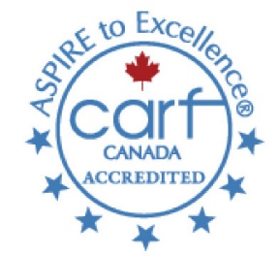
CARF Accreditation
SACL Aspires to Excellence through the Accreditation process. Accreditation assists Service Providers to improve the quality of their services and meet internationally recognized standards of excellence.

Persons’ Supported have a variety of options when deciding what services to use and who should provide them. Accreditation is a sign of quality and is an important consideration in their decision making. They look for CARF accreditation in their choice of treatment for addiction and substance abuse, rehabilitation of a disability, home and community services, retirement living, and other health and human services.
The value of accreditation goes beyond a competitive distinction for service providers and a framework for continuous quality improvement.

SACL is proud to “ASPIRE to Excellence” through the CARF Accreditation Process.
What is ASPIRE to Excellence?
A – Assess the Environment
S – Set Strategy
P – Persons Supported and other Stakeholders (Obtain Input)
I – Implement the Plan
R – Review the Results
E – Effect Change
Thanks to your continual support and input, SACL has successfully obtained a full 3-year accreditation each time we have been surveyed through CARF (Commission on the Accreditation of Rehabilitation Facilities).
We have been a fully accredited agency since 2005.
We received our most recent 3-year accreditation in November of 2021. Our next accreditation Survey will take place in June of 2023

Governance and Leadership
SACL has a volunteer Board of Directors, with a membership made up of interested people who are committed to the delivery of high quality services.

New Board Members are elected at the Annual General meeting in the fall of each year, and serve for a two-year term. The Board may, from time to time by Board Resolution, appoint a person as a Director, provided that the number of Directors so appointed must not exceed two at any given time.

Administration
The Executive Director is responsible for the leadership, management, and financial health of the organization.

The Director of Services & Human Resources oversees the full day to day scope of services provided by the agency and the Human Resource Management.
The Services Managers oversee all aspects of the day to day operations for their designated programs.

The Quality Assurance Coordinator is responsible for maintaining the Association’s quality improvement cycle.

In addition, there are a number of full-time, part-time, and casual staff who supervise and direct services for Persons Supported.

SACL Membership

Shuswap Bookkeeping
Finances

Board of Directors

Faster than Light Computing
Technology Management

Executive Director
Jo-Anne Crawford

Director of Services & Human Resource
Karen Hansen
Quality Assurance Coordinator
Colleen Petrick

Community Employment Services
Job Development
Employment Supports

Home Share Services

Community Connector Network (CCN)

Community Inclusion

Health Wellness & Life Skills (HWLS)
One to One Supports

Supported Living Services

Residential, Cluster, SSHP

Services Manager
Lesley Campbell
Services Manager
Connie Sebelius

Services Manager
Joanne Reitan

What We Do
The Shuswap Association for Community Living Aspires to Excellence through quality person-centred service provision.
As an organization who is accredited by CARF (Commission on Accreditation of Rehabilitation Facilities), we are mandated to continually improve the quality of services by demonstrating effectiveness, efficiency, and service access, meeting internationally recognized organizational and service standards. Our objectives are to combine the Outcome Requirements from Community Living British Columbia and from the international accreditation body CARF to provide superior, forward-thinking, quality services to Persons Supported.
Access to Service

SACL remains committed to Persons Supported and recognizes their need for service. If a person meets the SACL entrance criteria requirements, but is unable to access service due to capacity, it is up to CLBC to place the individual on their waitlist. SACL provides a variety of alternative Community Inclusion based services through a variety of Individualized Funding & Community Support Services. SACL services are available to any individual not eligible through the CLBC process on a comparable ‘fee for service’ basis.

Dignity of Risk
SACL acknowledges that all Persons Supported have the right to succeed, but more importantly to sometimes fail. However, people with disabilities are very often “protected” from an opportunity to fail by those around them who want to shield them from the disappointment of failure and the reality of life as an adult. This approach limits Persons Supported from setting personal goals and trying to achieve them and limits growth. Trying in itself is admirable and learning from mistakes provides opportunity for growth and movement toward independence. Every person, with disabilities or not, needs an environment which encourages trying and offers positive opportunities to learn from mistakes and successes. All Person’s Supported, consistent with their strengths, abilities and needs, will be given opportunities to take risks and in some cases fail. Each step towards achieving a big goal is positive, and encourages growth.

Shuswap Self Advocates Bill of Rights
I have the right to:
Confidentiality of my information
  - no one talks about me without me knowing
The right to my privacy
  - to not be disturbed or bugged when I want quiet time
  - I have the right to be heard
Legal entities for appropriate representation
  - the right to have the person of choice to help speak for me
  - I have the right to be heard
  - a lawyer
Self-help support services
  - to have access to a service, and have the service done the way I want
  - join support group(s) of my choice
Advocacy support services
  - to belong to a peer group that helps speak out for me
  - I have the right to speak my mind
Investigation and resolutions of alleged infringement of my rights
  - to have the person of my choice check on my rights when I want
  - I have the right to speak my mind

The rights of any other individual
  - I have the right to be treated with respect
  - I have the right to speak
  - I have the right to get married
  - I have the right to choose my own friends
  - I have the right to eat what I want to eat
  - I have the right to choose where I want to go
  - I have the right to choose where I want to live
  - I have the right to decide how to spend my money
  - I have the right to say who touches my body
  - I have the right to choose what I want to read and watch on TV
  - I have the right to privacy and intimate relationships
  - I have the right to choose if I want to go to church and which one to go to
  - I have the right to make mistakes
  - I have a right to forget the past
  - I have the right to take a break, have a rest and have some fun
  - I have the right to have meals
  - I have the right to make choices, with help, if I need it

I will have freedom from:
Abuse
  - I have the right to say who touches my body
Financial or other exploitation
  - someone using my money for themselves, uses me to get themselves money
Retaliation
  - hurt me because I spoke up for myself or complained about something
Humiliation
  - make me ashamed or hurt my feelings
  - I have the right to be treated with respect
Neglect
  - lack of care of myself

I will have Access to:
My information/records when I need it

I make the choice:
On service delivery
  - choice of services to access
Release of my information
  - my choice of who gets information about me
Concurrent services
  - the choice to attend more than one service
My services team
  - attend services with who I want and have help from who I want
  - I have the right to speak my mind

Do not fear mistakes. You will know failure. Continue to reach out.
Benjamin Franklin

Person Centred Plans (PCP) or Employment Plans
Each Person Supported who attends SACL will have in place a Person Centered plan (PCP) or an Employment Plan that reflects their:
- Strengths.
- Abilities.
- Preferences.
- Desired outcomes.
- Other needs, as identified by the Person Supported.
The PCP:
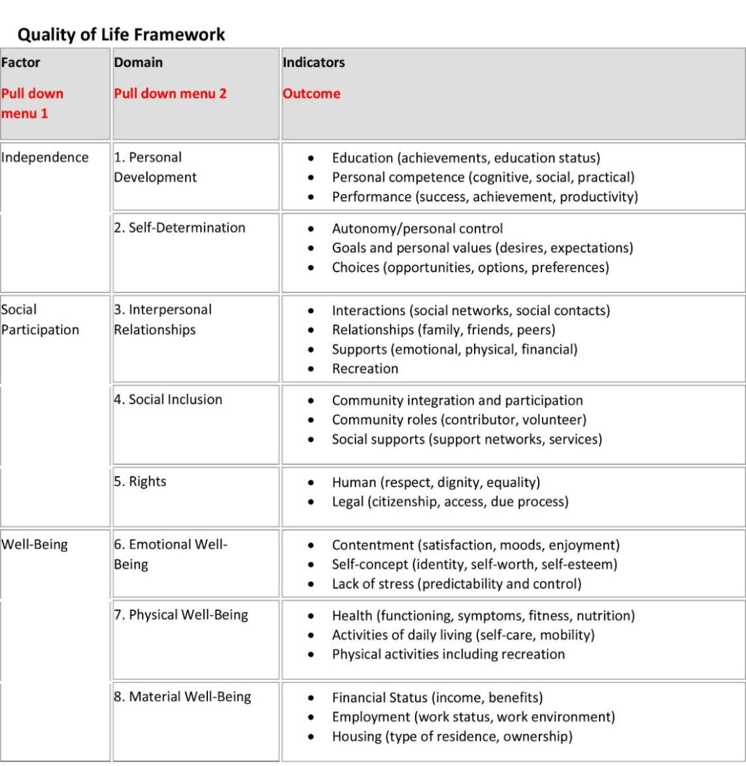
- Identifies specific measurable goals as outlined by Dr. Shalock’s Quality of Life Framework:

- Is developed with the active involvement of the Person Supported
- Identifies The Person’s overall outcomes, specific measurable goals, methods and techniques to be used to achieve goals, those responsible for implementation and how/when progress on objectives will be regularly reviewed
- Is communicated in a manner that is understandable to the Person Supported and the persons responsible for implementing the plan.
- Is reviewed on a regular basis (semi-annually or as needed) with respect to expected goals.
- Is revised on a regular basis (semi-annually or as needed) based on the changing needs and satisfaction of the Person Supported
- Reflects timely transition planning when moving from one level of services to another or to another provider for services.
In accordance with the Association’s value of promoting inclusiveness and self -determination, Persons Supported are to be assisted to develop their plans. Reasonable efforts and accommodations will be made to obtain the active participation and understanding of the one who is receiving services, including an advocate if needed, or if it is necessary to interpret the Person’s Supported desires. Plans focus on expected desirable goals /results that are achieved through participation in SACL services. Semi-annual reviews are essential to ensure goals are achievable and remain meaningful to the Person Supported.
Staff
SACL Staff meets or exceed the following qualifications:
- Community Support Worker Certificate or equivalent education and/or experience.
- Current certification in First Aid and CPR.
- Violence Prevention Training & MANDT Training.
- Depending on their position – may be required to provide a valid BC Drivers licence, and applicable insurance.
- As well, prior to being hired, prospective employees must pass a criminal record search, a physical exam, present a driver’s abstract as well as provide background checks from previous employers.

Key Worker System
SACL operates on a Key Worker system. This means that a Person Supported will be assigned to a Staff member who is responsible for their well-being while at SACL. Where operationally possible, Persons Supported may request a specific Key Worker. Most Staff Members are involved with each of the Persons Supported that attends SACL, but a Key Worker is responsible for ensuring awareness of any important information about what is happening at SACL. The Key Worker should be the first point of contact if there are questions or concerns. Changes in routines, medications or health status at home can affect a Persons Supported well-being and it is important that the Key Worker and other Staff Members know about these changes. We would ask that the Key Worker is notified as soon as possible if anything has changed.
Key Worker duties are as follows:
- To proactively consult with the Person Supported and their personal support network if there are questions or concerns.
- To review daily log notes from each service that is attended.
- To compile semi-annual reports and meet with the Person Supported to review the results. The report will be submitted to CLBC upon their request. With the Persons Supported consent, this report will also be sent to Caregivers, Family, or other people in their personal support network.
- Key Workers will contact Caregivers and/or Family for input and feedback on specific individualized goals, if the Person Supported agrees.

Individual/Stakeholder Input
Service Provision Meetings
Monthly discussions are held with Persons Supported to discuss schedules, issues, safety concerns, and to obtain any input for changes or improvements to SACL services or procedures.

Agency Information Distribution
Agency Information is circulated and published through the agency website, newsletters, brochures, emails, and informational correspondence.

Satisfaction Surveys
SACL puts out annual satisfaction surveys to Persons Supported, parents & caregiver, employers, stakeholders, community partners and staff to find out if you are happy with the services provided and what suggestions you have for areas of improvement. All results and improvement plans from the surveys are available in our annual Performance Measurement & Improvement Plan that is available on our website.

Costing & Fees
Depending on chosen activities by the Persons Supported, additional costs or fees may apply. All SACL services may be provided on a ‘fee for service’ basis if a person requesting services is not eligible to attend through the CLBC referral process.

Reasonable Accommodations
SACL will strive to provide reasonable accommodations, modifications, or adjustments that assist Persons Supported or Staff Members to access benefits and privileges that are equal to those that are enjoyed by others.
Accommodations will be determined on a case by case basis. Accommodations should be made wherever they are reasonable and do not cause undue or unjustifiable hardship to the Shuswap Association for Community Living.
Reasonable accommodations, modifications or adjustments could include making existing facilities readily accessible to, and usable by people with disabilities; restructuring jobs; modifying work schedules; reassigning people to vacant positions; acquiring or modifying equipment or assistive devices; adjusting or modifying training materials, policies and procedures; and providing qualified readers or interpreters.
If you feel that you need a reasonable accommodation, please discuss it with your Key Worker. They will assist you and your circle of support to make a request to the Executive Director.

Service Listing
SACL Provides the following Services:

Community Employment Services
- Job Development
- Employment Supports
Community Integration
- Health, Wellness & Life Skills (HWLS)
- One-to-One Supports (PEP)
- Community Connector Network (CCN)
Supported Living Services
Shared Living Services (Home Share)
Host Agency/Individualized Funding

For complete information on each program area, visit www.shuswapacl.com

Agency Policies and Guidelines

Visitors
Health, Wellness, & Life Skills regular hours of operation are from 9:00 to 3:00 Monday through Friday. Family Members, Caregivers or friends may visit during regular hours. We ask that you telephone ahead to arrange a time when you can visit. If you would like to meet with the Key Worker, we would again ask that you telephone ahead for an appointment.
Children under the age of 12 must be accompanied by an adult at all times.
We ask that visitors be considerate of our Person’s Supported schedules during the day and to not interfere with scheduled activities if possible.
Community Employment Services (CES) regular hours of operation are from 8:00 am – 4:00 pm. Please phone ahead for an appointment, as Employment Counsellors may be out in the community assisting others.
One-to-One Supports (PEP), and any Supported Living Services site requests that visitors call for an appointment to ensure optimal timing for the visit within the Person’s Supported schedule.

Change in Person Supported Routine/Schedule
- Schedule Change or Cancellation of Services – (ABSENTEE REPORTING LINE)
If Persons Supported are not able to attend SACL services or you wish to cancel services, or there is any change to the Person’s Supported routine, Please call the ABSENTEE REPORTING LINE ONLY by phoning the main office at 250-832-3885 and press 8, or dial direct to Extension 1100 to reach the ABSENTEE MAILBOX. Please do not call SACL Staff or Services Managers directly, but report all changes in Person’s Supported routine to the ABSENTEE REPORTING LINE ONLY. Contacting the ABSENTEE REPORTING LINE will ensure that all staff and departments are properly informed of any change, and to help eliminate any possible communication issues that may affect service provision. (Thank You).

Persons Supported will not be released from their Services for lunch, coffee etc. with friends, relatives etc. without prior authorization.
Prior authorization may include a written standing order that a family member or other involved person always has the permission to pick the Person Supported up.
- Emergency Contact Change
Please advise SACL Staff anytime there is a change to emergency contacts.

Persons Supported Responsibilities
Persons’ Supported responsibilities include, but are not necessarily limited to, the following:
- To participate fully in your chosen service(s);
- To share medical/medication information promptly with staff;
- To stay home when you are ill and to notify SACL office ASAP at
250-832-3885 and press 8 for the Absentee Reporting line (Extension 1100);
- To arrive and leave programs as per your regular schedule and to inform staff of any changes to that schedule;
- To schedule appointments outside of program hours and if unable to, to notify SACL as soon as possible;
- To respect the rights and property of other individuals and of program staff;
- To work towards the mutually established outcomes of your individual service plan;
- To inform staff of any medical conditions or communicable diseases;
- To follow all safety rules and participate in emergency drills.

Medication Policy
If a Person Supported requires medication during their time at SACL, the following must be observed:
- Medications must be clearly labelled with the Person’s Supported name, the medication, the administration time and the dosage in a blister package for each Person Supported. This includes PRN (as needed) medications. Medications will be dropped off by caregivers/family directly to SACL Staff.
- A monthly medication administration record (MAR) must also be provided with the Person’s Supported name, the medication and the dosage for each Person Supported.
- Medications will be kept under lock and key.
- Staff will administer the medication at the appropriate time, and in accordance with the SACL Medication Administration Policy.
- If there are any changes in dosage, administration time etc. SACL must be notified before the next dose is due by the PIC (person in charge, caregiver, responsible family member)

General Health & Safety Rules
General Health & Safety rules apply to all Employees, Persons Supported and contractors at SACL. Health & Safety rules are intended to ensure that SACL is a safe place and must be followed without exception.
Reporting of Injuries
Persons Supported are required to immediately report all injures to Staff. You may require medical clearance to return to your full service schedule. SACL will make every attempt to accommodate a “light duty” schedule if necessary.

Illness
Contagious diseases spread from one person to another. Often, people who spread disease do not look or feel sick. The germs spread by direct contact
(touching), by coughing or sneezing, or by germs from the stool (bowel movement) or by blood getting on surfaces.
Maintaining health and preventing the spread of contagious diseases are responsibilities shared by Persons Supported, Caregivers, family Members, and SACL Staff.

Persons Supported are to stay home if they are feeling ill. If a Person Supported arrives at the Association and is ill or becomes ill while at the Association, the caregiver and/or family member will be notified and the Association will request that the Person Supported be picked up immediately.

The Association MAY require a physician’s clearance note if the Person Supported has missed or is missing time due to repeated bouts of illness.
Alcohol and Drugs
No Person Supported will be permitted to enter or remain on the premises while his or her abilities are effected by alcohol, drugs, or other substance as to endanger his or her health or safety or that of any other person. According to SACL Policy, staff are not permitted to consume alcohol or drugs of any kind while providing SACL services.
Use or Possession of Weapons
Use or possession of weapons is strictly prohibited.

Smoking
In accordance with SACL policy to provide a smoke-free environment and with WCB Reg. 4.81(a), smoking is not permitted within any SACL building or vehicle.
Improper Activity or Behaviour
To reduce the likelihood of challenging behaviour, SACL strives to create environments in which all persons feel safe. SACL staff are thoroughly trained to support persons who experience challenging behaviour and deescalate situations using positive behaviour support and interventions and the least intrusive techniques needed to keep everyone safe.
Reporting of Unsafe Conditions
Persons Supported are required to report any unsafe or harmful conditions to Staff. The Staff must ensure that any necessary corrective action is taken without delay except in the case of an emergency where action must be taken immediately.

Scent Free
Some people are very sensitive to scents and fragrances in personal care, cleaning products, and tobacco smoke. Sensitivity can mean headaches and migraines, eye, nose, and throat irritation, or illness. Scents and fragrances can also affect people who suffer from asthma and other chronic lung diseases. Therefore, SACL Services and vehicles have been designated as “Scent Free”. Please use “Scent Free” products while at SACL.

Conflicts of Interest, Including Outside Employment and Gifts
SACL recognizes the right of employees to be involved in activities as citizens of their community. However, Staff Members must keep their role as private citizens separate and distinct from their responsibilities as employees.
Employees should not place themselves in a situation where they are under obligation to any person who might benefit from or seek to gain special consideration or favour. The honesty and impartiality of employees must be above suspicion.
No staff Members shall accept compensation or rewards from Persons Supported or agencies because of the position they occupy in the Association. Money or other gifts offered should be firmly but kindly refused.
No employee shall sell goods or services to a Person Supported nor accept money or (i.e.) meals/coffee or loans from a Person Supported.

Complaint Resolution Process & Service Quality Advocate
SACL Complaint Procedure
If a Person Supported is not satisfied with the services that they are receiving from SACL they have the right to complain. The complaint will not jeopardize future service in any way. In fact we appreciate a person’s efforts to let us know if aspects of services are unsatisfactory. All input, both positive and constructive, helps us continue to improve our service delivery and address service gaps.

First Step
We encourage people to talk directly to the person involved. A person may wish to seek the support of their key worker or Services Manager. Very often, situations and problems can be solved quickly at this level. All complaints must be addressed in writing and contain a proposed solution.
If there is still a problem...
If this does not provide satisfactory results, please contact the Executive Director. The Executive Director will immediately initiate an inquiry. The process may include one or more of the following and will be concluded within 7 business days:
- Talking to the person on the telephone and/or meeting with them in person.
- Talking to the person and the other person involved.
- Reviewing documentation.
- Having a team meeting to come up with workable solutions.
The Executive Director will provide written notification to the person with the complaint regarding the actions to be taken in resolving the issue.
If the outcome of the above is still not satisfactory…
If still unsatisfied with the above, the person has the right to appeal to their Community Living BC worker.
If still unhappy about the outcome after speaking with the worker (change to “their Community Living BC Worker”, contact the Advocate for Service Quality.

Community Living BC Complaint Procedure
If, following eligibility acceptance and planning with a facilitator, Community Living BC (CLBC) does not provide any support or inadequate levels of support or you feel that you have been treated inappropriately, there is a CLBC Complaint Resolution Process. Information is available on their website https://www.communitylivingbc.ca/how-do-i-get-support/request-review-complaints-process/file-a-complaint/

Step One:
There are three ways to file a complaint:
- Use the on-line form which can be found on the Community Living BC front page www.communitylivingbc.ca
- Contact CLBC Quality Assurance Office directly at 1-855-664-7972.
- Visit any CLBC office and ask staff to assist with filling out a short form.
Step Two:
A regional review will be conducted and a response, giving a decision, recommendation(s) will be provided.
Step Three:
If you are not satisfied following a review of the complaint you should contact CLBC’s Manager of Quality Assurance directly at 1-855-664-7972 or ComplaintsResolutionCLBC@gov.bc.ca. The Manager will contact you within 72 hours, initiate a review and provide a written response within 10 days.
If you are not satisfied with the Quality Manager’s response, you will be invited to contact CLBC’s Vice President, Regional Operation who will conduct a review and submit a written decision to you within 10 days.
Vice President, Regional Operations: John Stinson
Address: 7th Floor, Airport Square
1200 West 73rd Avenue
Vancouver BC V6P 6G5
Phone: 604-664-0101
1-877-660-2522 toll free
At any time during the CLBC process above you may and should also take the following steps:
- Contact your MLA
- Contact Inclusion BC
- Contact the Advocate for Service Quality
- Write to the Minister responsible for Community Living BC.
- Write to the opposition party.
- Write to the Premier.
- When the issue concerns a youth about to transition to adulthood, contact the Representative for Children and Youth
- Contact the BC Ombudsperson
- Contact the Family Support Institute (FSI)
1. Contact your MLA
Name: Greg Kyllo
Address: PO Box 607
Suite 202A – 371 Alexander Street NE
Salmon Arm, BC V1E 4N7
Phone: 250-833-7414
Toll Free: 1-888-771-7557
Email: greg.kyllo.MLA@leg.bc.ca
To find your local MLA, visit https://www.leg.bc.ca/pages/bclass-search-constituency.aspx
2. Call or Email Inclusion BC
Inclusion BC's mission is to advocate for children, youth and adults with developmental disabilities and their families to ensure justice, rights and opportunities in all areas of their lives. You can contact Inclusion BC if you need someone to advocate for you. Sometimes they will connect you with someone in your community who can help, and other times they will get involved directly with your situation.
Web: www.inclusionbc.org
Phone: 1-844-488-4321
Email: advocacy@inclusionbc.org
3. Advocate for Service Quality, Leanne Dospital.
Phone: 1-800-663-7876
Email: ASQ@gov.bc.ca
Web: www2.gov.bc.ca
4. Contact the Minister responsible for Community Living BC.
Nicholas Simons, Minister of Social Development & Poverty Reduction
Address: Room 247 Parliament Buildings
Victoria, BC V8V 1X4
Phone: (250) 356-7750
Email: sdpr.minister@gov.bc.ca
5. Write to or call the opposition critic for Community Living BC.
Visit the Liberal website to find out who the current opposition critic is for Community Living BC.
You can also reach him/her toll-free by calling Enquiry BC and asking for the Official Opposition Caucus: 1-800-663-7867
6. Write to the Premier, John Horgan.
https://www.leg.bc.ca/
Phone: 250-387-1715
Fax: 250-387-0087
Email: premier@gov.bc.ca
7. The Representative for Children and Youth
If your family member is a youth transitioning to CLBC’s adult services, or is between 19-24 years old, you can contact the Representative for Children and Youth.
Contact: Dr. Jennifer Charlesworth
Phone: 1-800-476-3933.
Web: https://www.rcybc.ca/
8. The BC Ombudsperson is
• an officer of the provincial legislature, independent of government and political parties responsible for making sure that the administrative practices and services of public agencies are fair, reasonable, appropriate and equitable.
Phone: toll-free at 1-800-567-3247
Web: https://www.bcombudsperson.ca/
9. The Family Support Institute (FSI)
Staff in the FSI office can help navigate systems and connect you to other family members who are volunteer Resource Parents for support.

Phone: 604-540-8374 (Ext. 523) or toll free 1-800-441-5403

www.familysupportbc.com

Legal Aid
If you have a legal problem but can’t afford a lawyer, the Legal Services Society (LSS) may be able to help you. LSS is an independent, non-profit organization that provides legal aid for people with low incomes in BC.
Legal aid services range from legal information and legal advice to legal representation (a lawyer to handle your case). To get a lawyer to represent you, your legal problems must be covered by LSS and you must qualify under financial eligibility guidelines. There is also a financial eligibility test for legal advice services.
To apply for legal representation but you can’t get to a legal aid office, phone the provincial Legal Services Society Call Centre :
9:00 a.m. to 4:00 p.m. Monday, Tuesday, Thursday, and Friday
9:00 a.m. to 2:30 p.m. Wednesday.
For more information call 1-866-577-2525 or on the web at http://www.lss.bc.ca/

SACL Contacts
SACL Services & Departments  #301, #103 & #101 – 371 Hudson Ave NE  Mailing Address:  PO Box 153, Salmon Arm BC, V1E 4N3  Telephone – 250.832.3885  Fax – 250.832.1076  Phone Extensions:  To Report an Absence or Change in Service Provision: 1100  Health, Wellness & Life Skills Services: 1110  Community Employment Services: 1310  Personal Enrichment Program (PEP) 1111  Administration: 1300  Jo-Anne Crawford, Executive Director: 1301  j.crawford@shuswapacl.com  Karen Hansen, Director of Services: 1305  khansen@shuswapacl.com  Joanne Reitan, Services Manager: 1102  jreitan@shuswapacl.com  Connie Sebelius, Services Manager: 1306  csebelius@shuswapacl.com  Lesley Campbell, Services Manager  778-489-1207  lcampbell@shuswapacl.com | SACL Board Chair C/O  PO Box 153  Salmon Arm, BC V1E 3B5  Community Living BC  Salmon Arm  Suite 202, 351 Hudson Avenue NE,  PO Box 100, Station Main  Salmon Arm, BC V1E 4S4  Phone: 250-832-1718  Community Living BC  Vernon  Suite 201, 2802 – 30th Street  Vernon, BC V1T 8G7  Phone: 1-250-549-5490

Service Closure Dates:
Health, Wellness & Life Skills and the Personal Enrichment Program are open to Persons Supported from 9 am to 3 pm. Break times are usually at 10 am and 2 pm and last 15 minutes. Lunch is typically at 12 pm and lasts 30 minutes. Persons Supported are to bring their own lunches, unless other arrangements have been made. You will be notified of any changes.
All Community Based Services are closed for all statutory holidays. Where a statutory holiday falls on a weekend, the Monday immediately following the weekend holiday will be observed.
2022 Health Wellness & Life Skills and Community Connector Network Program Closure Dates
February 4th & 11th
June 10th
September 22nd & 23rd
October 21st
December 23rd, 28th, 29th & 30th
The Health, Wellness & Life Skills will provide you with a calendar of events on a monthly basis.

